ClearSol: A Self-Cleaning Solar Power System

Fabio Amado, Zachary Capone, Julian Leguizamon, Ryan Rosenberger*,* and Anthony Saab

**Project Summary**—ClearSol is a self contained solar array in which an Electrodynamic Screen (EDS) is applied over the solar panel. In the case dust accumulates on the panel, the film can be charged, this expelling dust utilizing static electricity. We aim for our design to be fully self-contained, capable in an extreme range of temperatures, and able to power the film by itself as well as be able to export a steady supply of electricity from the unit.

————————————————

* *Fabio Amado is with the Department of Electrical and Computer Engineering, Boston University, Boston, MA 02215. E-mail:* [*famado@bu.edu*](mailto:famado@bu.edu)
* *Zachary Capone is with the Department of Electrical and Computer Engineering, Boston University, Boston, MA 02215. E-mail:* [*zcapone@bu.edu*](mailto:zcapone@bu.edu)
* *Julian Leguizamon is with the Department of Electrical and Computer Engineering, Boston University, Boston, MA 02215. E-mail:* [*julianle@bu.edu*](mailto:julianle@bu.edu)
* *Ryan Rosenberger is with the Department of Electrical and Computer Engineering, Boston University, Boston, MA 02215. E-mail:* [*rjrose@bu.edu*](mailto:rjrose@bu.edu)
* *Anthony Saab is with the Department of Electrical and Computer Engineering, Boston University, Boston, MA 02215. E-mail:* [*saabanth@bu.edu*](mailto:saabanth@bu.edu)

—————————— ◆ ——————————

# 1 Need for this project

ONE of the key weaknesses of photovoltaic (PV) systems is that their efficiency weakens over time if not maintained properly. While maintenance of solar panels can be low cost, it becomes time consuming and less efficient for larger systems such as solar farms and difficult for systems installed in far-off locations such as lunar and mars installations. Depending on the environment solar panels efficiency can decrease up to 25% [1]. There is a need for automated cleaning in solar panels in the space and energy industry. Dust mitigation is a major problem for outer space exploration in locations such as the Moon and Mars. As water is non-existent in these locations, maintaining a clean solar panel is difficult and there is no way to do maintenance on these panels [2]. Solar power systems are a major aspect of NASA’s lunar and mars missions and these systems need to be able to last years.

This weakness carries over to terrestrial solar installations. Since the majority of solar farms are located in arid and desert environments it becomes difficult to do maintenance. These plants encompass large areas of land of around ten to hundreds of acres. The way maintenance is done in these solar farms is by using automated water cleaning systems or manual labor with hoses to wash them down. Currently, industry costs for cleaning a solar farm range from $0.50-$1.00 per module. This would equate to a range of $8000-$16,000 to clean the Goldtree solar farm [3].

Ultimately, this project aims to provide a solution to maintaining a clean and efficient solar power system in both terrestrial and extraterrestrial applications.

# 2 Problem Statement & Deliverables

## 2.1 Problem Statement

When in the field, be it terrestrial or extraterrestrial, solar panels lose efficiency to the dust, dirt, and debris which inevitably blow onto the panel. As a consequence of this buildup, efficiency of the solar panel is continually reduced as more and more surface area is covered by the debris. As a consequence of this issue, large solar farms in places they would be most efficient, such as a desert, become unrealistic as cleaning off the sand is too resource intensive. This is also true for aerospace applications, as sending someone to clean the panels is not an option. In order to solve these issues regarding the situational application of solar panels, Group 29 is presenting ClearSol.

ClearSol is a proof of concept utilizing the application of the EDS in both terrestrial and extraterrestrial environments, and consequently, a self contained set of circuitry in which solar energy is diffused and modified in order to be exported as a steady flow of electrical energy.

.

## 2.2 Deliverables

By the end of our project, the customer will receive a prototype of the design which is capable of properly powering and utilizing the Electrodynamic Screen producing a net positive output of electrical energy as well as being capable of providing power within a variety of temperature conditions, including those below freezing as would be faced on Mars. The prototype will also contain an array of sensors which measure both temperature and the amount of voltage being output by the system.

# 3 Visualization

The system is powered by a PV module placed on top of the case containing the electronics. The module is directly connected to an MPPT (maximum power point tracking) charge controller. This charge controller selects the optimal operating point (V,I) of the PV module such that they output the maximum power possible. A supercapacitor energy storage system is directly charged by the PV module. These supercapacitors allow us to store energy in very cold environments like on the surface of Mars, where other standard energy storage technology would not operate in an efficient manner (Li-ion batteries for example). They then output a DC voltage to an inverter and a Buck-boost converter. Since these supercapacitors have a very large capacitance, they allow for the low-pass filtering of the DC output, allowing for a smoother and more consistent output than what the panels generate (The power generated by the panels is somewhat inconsistent since it is heavily dependent on the weather conditions and environment). The inverter then transforms the DC voltage into a 24 Vpp AC voltage. The current goes through an ammeter and is then used to power a load that consumes a maximum of 10 Wp. The buck-boost converter on the other end, transforms the filtered DC output voltage from the supercapacitors to a stable 12 V DC voltage. This voltage is used as an input to the Electrodynamic Screen (EDS) power supply. This power supply outputs a three-phase 1.3kV square-wave to the EDS film that is installed on top of the surface of the PV module. When the EDS is triggered, a dynamic electric field is generated on top of the panels, charging dust and sweeping it off the surface. We are also implementing a monitoring system that tracks the power consumption and generation of the system using data collected from the charge controller and the ammeter. We are also collecting data on the illumination of the panels using photosensors located near the surface of the panel. This data is fed to a microcontroller (Raspberry Pi, or something similar that is more power efficient), that computes the relevant information and displays them on an LED screen. The microcontroller is also responsible for triggering the EDS.

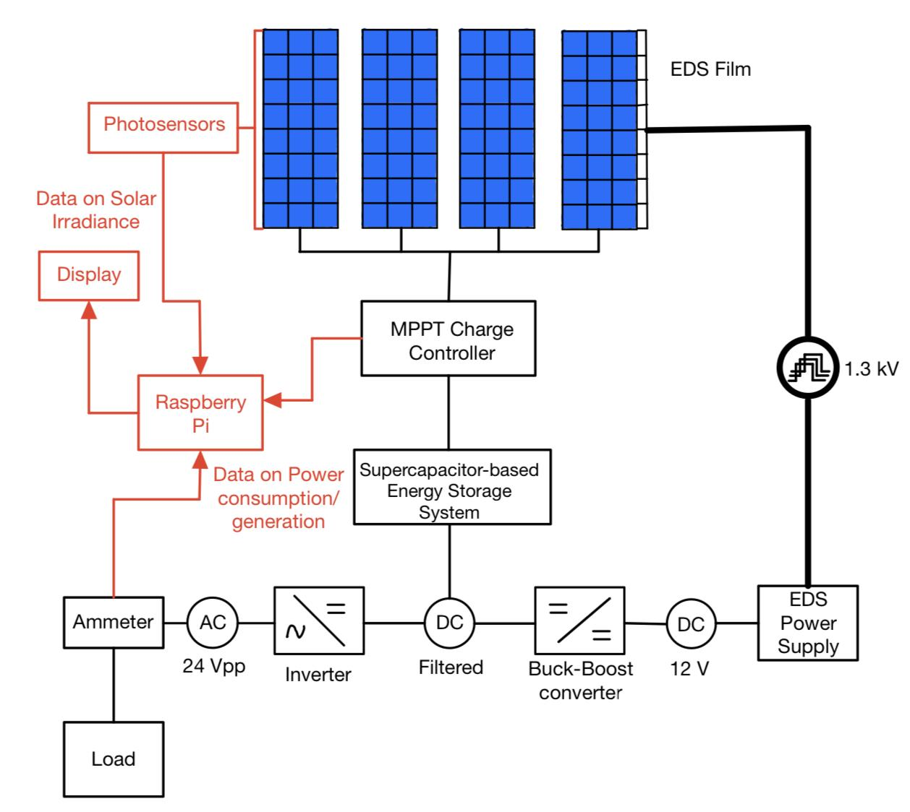

Figure 1.1 Single line diagram of the Solar Power System including the EDS self-cleaning technology.

# 4 Competing Technologies

Scientists and engineers from across different industries and fields have proposed solutions to find a solution to self cleaning solar panels. Some of the most promising of these solutions are Ecoppia E4, ARC Systems and Perma-Clean Solar Nanocoating.

## 4.1 Ecoppia E4

Ecoppia E4 is a robotic solution to the problem of solar panel cleaning developed by the Israeli based company, Ecoppia Scientific. The E4 robot is a fixed autonomous robot that utilises microfibers and controlled airflow to move the dust particles downward and off the solar panels. The robot moves up and down along a rigid aluminum frame using wheels that are coated in a special chemical that ensures that they will not damage the panels. There are five motors on the robot, 2 motors drive the horizontal movement and 2 drive the vertical movement. The 5th motor operates the rotation of the microfibers. The E4 robot is able to clean at a rate of 54 square feet every 30 seconds and requires no external power source. The E4 uses their own dedicated solar panels to charge on board batteries it uses to operate the motor functions of the robot. One requirement that the Ecoppia E4 robot and our EDS films have in common is that both systems must operate in environments where water is inaccessible. Ecoppia E4 is currently deployed in solar farms around Israel and the Middle East in areas with high amounts of dust storms and low rainfall and moisture. The robots and their microfibers do not rely on any sort of water for coating, lubrication or cooling of any sort. The main driver behind the development of this robot was to cut costs by eliminating the need for manual labor and water waste previously needed to clean solar panels [4].

## 4.2 ARC Systems

Anisotropic Ratchet Conveyors System or ARC System is a method of effective solar self cleaning developed by Dr. Sun and Dr. Bohringer at the University of Washington. The self cleaning surface utilizes a combination of both micro sized features and mechanical vibrations. The features consist of hydrophilic curved rungs on a hydrophobic background that have water droplet transportation characteristics. The system works by applying a single drop of water that is then used to systematically clean the surface contaminants. The drop is applied on the ARC and then moved around a predetermined track in order to cover as much surface as possible and remove dust particles from the panel. This system is similar to ours in that it is a sort of film that is applied on top of the panel, but it uses small amounts of water and a fundamentally different approach to removing dust as our EDS films [5].

## 4.3 Perma-Clean Solar Coating

Perma-Clean Solar is a transparent coating, made by the company DryWired, that is designed to increase the efficiency of solar panels. It is a chemical solution that alters the electrical resistance of a surface and provides anti-soiling properties to the panels. Additionally, the coat has hydrophilic and self cleaning properties that allow dust particles to be easily removed using water. Although this product does provide some self-cleaning properties, it still requires significant manual labor as it needs to be applied every few weeks and must be washed off with water in order to remove particles from the panel [6].

# 5 Engineering Requirements

This section describes project requirements, organized by subsystem.

## 5.1 Power

1. The system must store enough energy to sustain continuous measurement, control, and cleaning operations regardless of solar insolation.
2. Energy storage will ideally be composed solely of supercapacitors, but lithium ion batteries may be used if necessary.
3. A DC-DC converter will be used to provide a constant 12V DC system voltage.
4. The system must provide a 24V p-p AC output, at a peak power of 10W.

## 5.2 Panel Cleaning

1. The system must implement an electrodynamic screen and accompanying power supply to clear off accumulated debris on the panel.
2. A system voltage of 12V will be continuously maintained to supply the EDS power supply.

## 5.3 Monitoring

1. The system must monitor solar insolation.
2. The system must monitor charge levels of onboard storage.
3. The system must monitor output power.
4. The system must monitor solar panel efficiency loss due to accumulated debris on the panel.
5. The system must display performance metrics on an externally facing display.

## 5.4 Mechanical

1. The system must have all components except the solar panels enclosed.
2. The enclosure must prevent water and dust ingress.

## 5.5 Environmental

1. The system must be able to withstand temperatures in the range of 20C to -63C
2. The system should be able to withstand inclement weather conditions

**Acknowledgment**

The authors wish to thank Professor Malay Mazumder for continued support throughout the project.

**References**

1. A. Thompson, “Pollution could block 25 percent of the light that would become solar power,” Popular Mechanics, 15-Feb-2018. [Online]. Available: [Solar Panel Efficiency Dramatically Reduced by Dirt and Pollution](https://www.popularmechanics.com/science/energy/news/a27112/pollution-can-block-25-percent-of-solar-power/#:~:text=They%20found%20that%20solar%20panels,of%2035%20percent%20or%20more). [Accessed: 22-Oct-2021].
2. Malay K. Mazumder, Life Fellow, IEEE, Mark N. Horenstein, Life Fellow, IEEE, Nitin R. Joglekar, Member, IEEE, Arash Sayyah, Jeremy W. Stark, Annie A. R. Bernard, Sean M. Garner, Julius E. Yellowhair, Hung Yi Lin, Ryan S. Eriksen, Alecia C. Griffin, Yujie Gao, Ricci La Centra, and Alexis H. Lloyd, “Mitigation of Dust Impact on Solar Collectors by Water-Free Cleaning with Transparent Electrodynamic Films: Progress and Challenges” IEEE Journal of Photovoltaics, Vol. 7, No. 5, September 2017.
3. Stockburger, S., &amp; Rios, V. J. (2020). Energy and Economic Losses due to Soiling on Utility Scale PV Systems to Guide Timing of Cost Effective Cleaning. Digital Commons @ Cal Poly. Retrieved October 22, 2021, from <https://digitalcommons.calpoly.edu/cgi/viewcontent.cgi?article=1530&amp;context=eesp#:~:text=Currently%2C%20industry%20costs%20for%20cleaning,and%20decrease%20the%20profit%20margin>.
4. “Products and Services - Ecoppia - Robotic Solar Cleaning Solution." [Products and Services](https://www.ecoppia.com/products-and-services/). Accessed 20 Oct. 2021.
5. "An active self-cleaning surface system for photovoltaic modules...." 21 Sep. 2020, [An active self-cleaning surface system for photovoltaic modules using anisotropic ratchet conveyors and mechanical vibration | Microsystems & Nanoengineering](https://www.nature.com/articles/s41378-020-00197-z). Accessed 20 Oct. 2021.
6. "Perma-Clean Solar - Drywired® | Multifunctional Nanocoatings." 6 Jan. 2016, [Perma-Clean Solar](https://drywired.com/perma-clean-solar/). Accessed 20 Oct. 2021.